Name: Sandhiya R
Reg No: 192511132

EXP NO 2:
DATE: 01/08/2026
CREATE A SIMPLE CLOUD SOFTWARE APPLICATION FOR FLIGHT RESERVATION SYSTEM USING ANY CLOUD SERVICE PROVIDER TO DEMONSTRATE SAAS.
AIM:
To create a simple cloud software application for flight reservation system using any cloud service provider to demonstrate SaaS.
PROCEDURE:
step1: Go to zoho.com.
step 2: Log into the zoho.com.
step 3: Select one application step.
step4: Enter application name as flight reservation system.
step 5: Created new application flight reservation system.
step 6: Select one form
step 7: The software has been created.
IMPLEMENTATION: 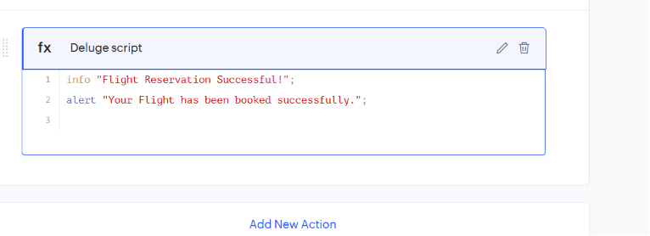

OUTPUT
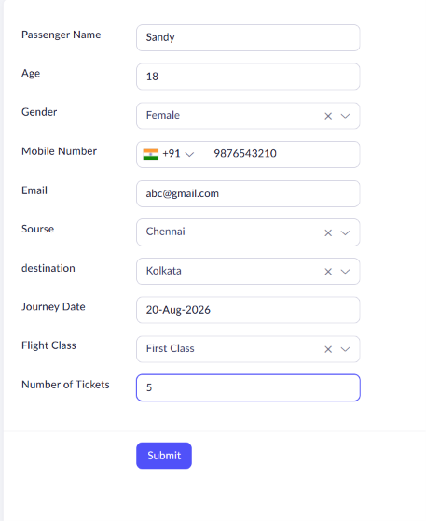

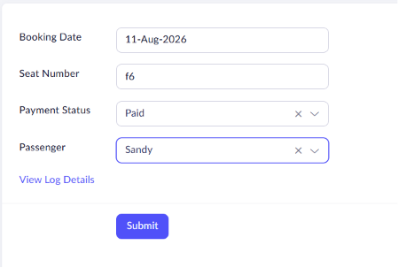
RESULT
The Flight Reservation System was successfully created using Zoho Creator. Passenger details and booking information were stored successfully, and the application demonstrated Software as a Service (SaaS) by allowing users to manage flight reservations through the cloud.

